BUTTERWORTH FILTER USING OP-AMP LTC6241

Introduction:
An electric filter is a frequency selective circuit that passes a specific band of frequencies and blocks or attenuates signals or frequencies outside the band.
Filters are categorised into many types depending on the type of signals and the particular components that go into its making. The Butterworth filter is one many filters amongst namely Chebyshev, Bessel and Elliptical.

Butterworth filter is a type of signal processing filter designed to have as flat a frequency response as possible in a passband. It is also referred to as a maximally flat magnitude filter. It has a monotonic drop in gain with frequency in cut-off region and a maximally flat response below cut-off frequency. Although Butterworth filters achieve the sharpest attenuation, their phase shift as a function of frequency is non-linear. The Butterworth filter has characteristics somewhere between Chebyshev and Bessel filters. Butterworth filters can particularly be made into a high or low pass filter along with the degree of order depending on the connection of R(resistor) and C(capacitor) and the number of R and C networks respectively.

The second order low pass filter has an advantage over and equivalent first order filter that is, the gain rolls of very fast after the cut-off frequency in the stop band. An additional RC filter added to a first order filter makes it a second order. The flatness of the curve increases as the order of the filters increased.

About the opamp:
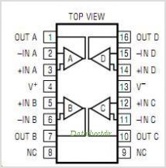
The LTC6240/6241/LTC6242 are single, dual and quad low noise, low offset, rail-to-rail output, unity gain stable CMOS op amps that feature 1pA of input bias current. Input bias current is guaranteed to be 1pA max on the single LTC6240. The 0.1Hz to 10Hz noise of only 550nVP-P, along with an offset of just 125μV are signifi cant improvements over traditional CMOS op amps .

Schematic and Simulation working:
To implement the AC analysis, we can apply an ac sweep to the input to get a frequency domain and observe roll over characteristics. (Fig.1 and Fig.2)
We can also implement a PLW analysis by changing the input of the ac sweep to a piecewise linear waveform. A piecewise linear voltage source consists of a series of voltages specified at certain instances in time with a linear change in voltage between them. (Fig.3 and Fig.4)
From the PWL output we can conclude that although the filter has an excellent pass band performance, it is a poor filter to use if trying to maintain the shape of a pulse.
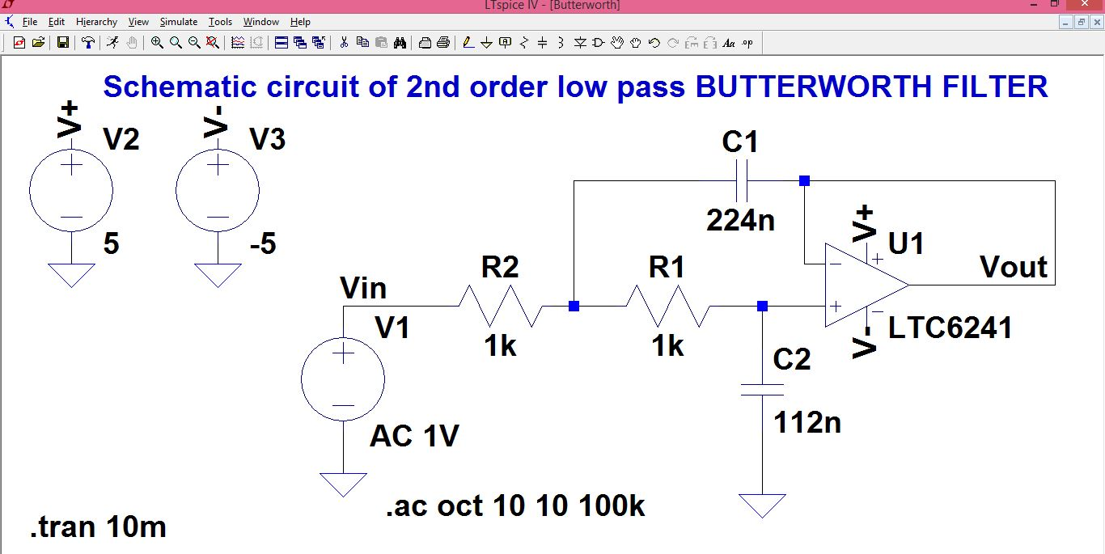
Fig1.

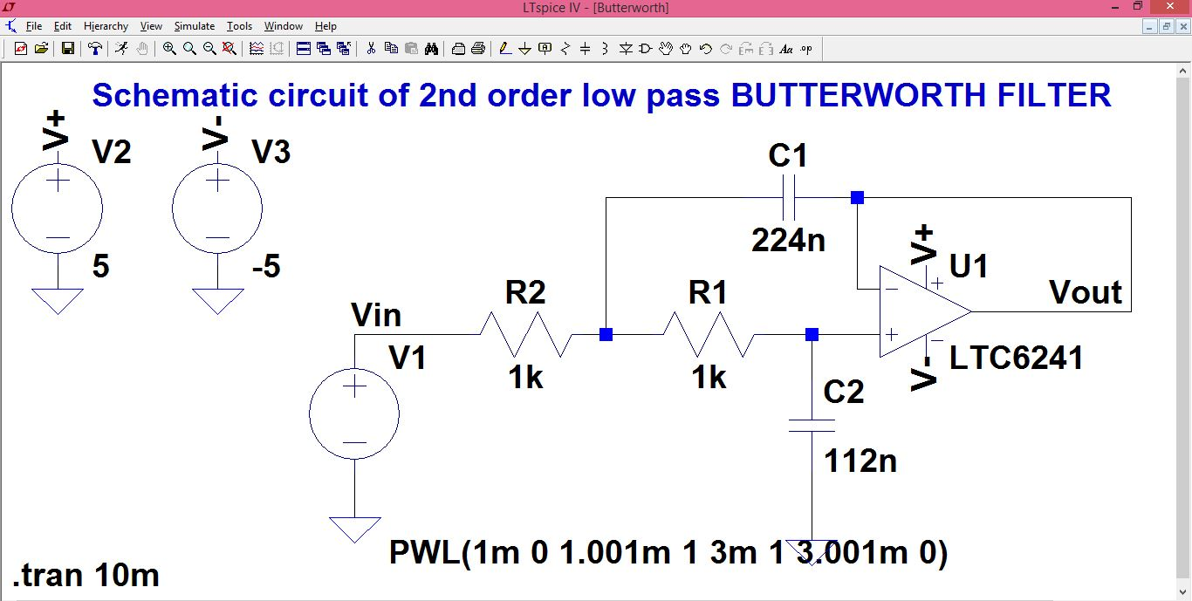
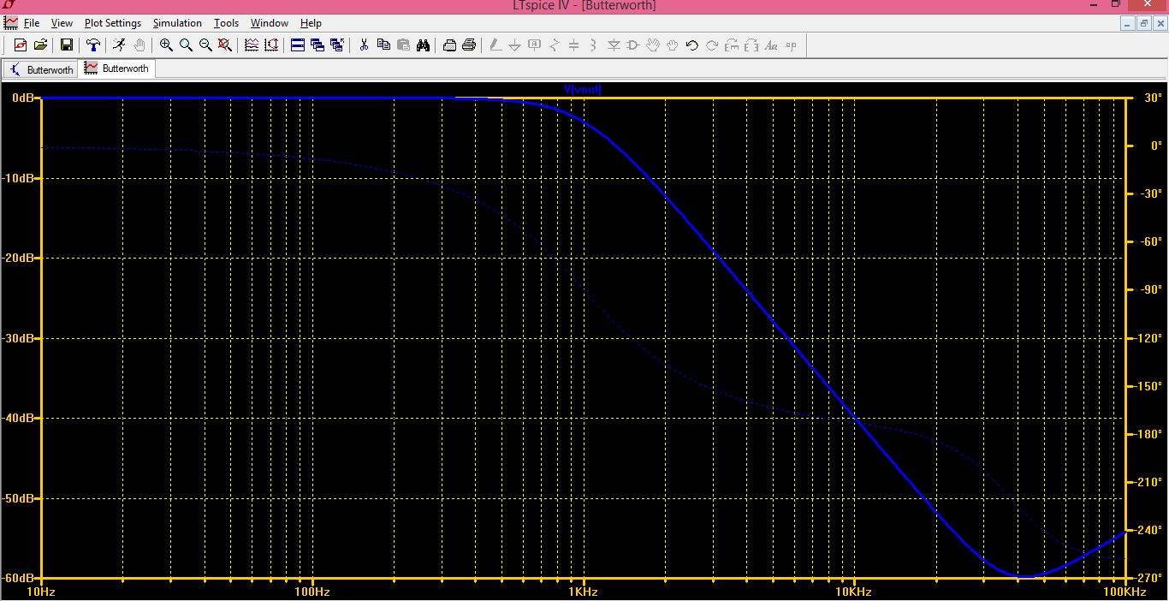
Fig2.

Fig.3

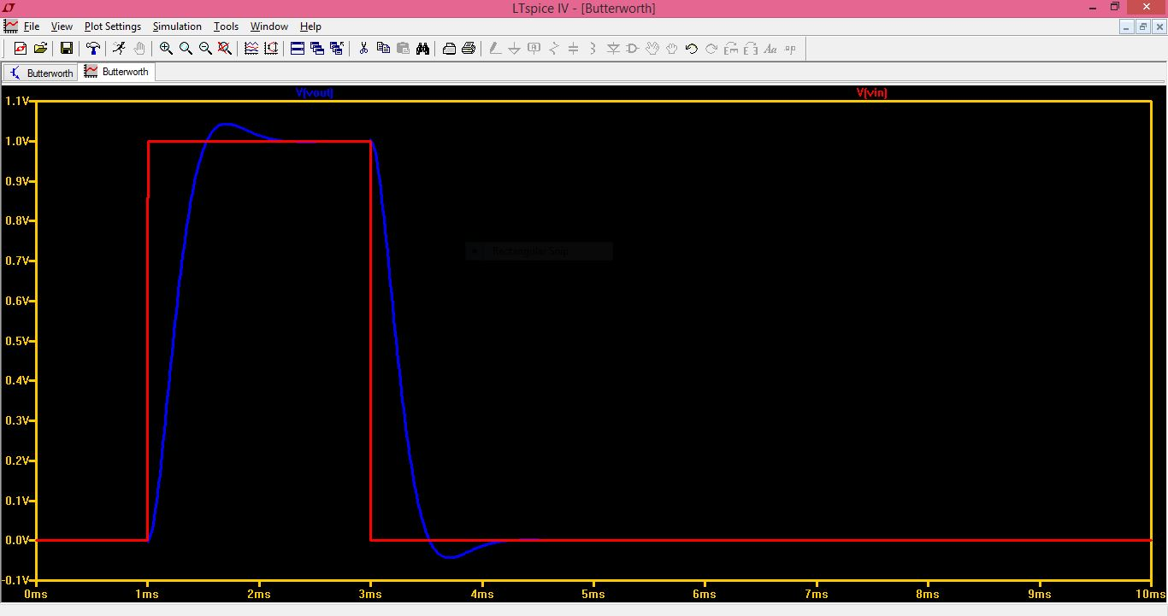
Fig.4

Applications:
Due to its maximum flat pass band nature, it is used as an anti aliasing filter in data converters.
It has applications in radars, in designing the display of radar target track.
Used in high quality audio applications.
They are used in digital filters for motion analysis.

